Write a short paragraph in your own words defining what a 'program' is and give one real-life example from any app you use daily (like Instagram, Zomato, or Paytm).
A program is a set of instructions that tells a computer what to do. For example, when we open Zomato and click an item to add it to the cart, the program processes our action and adds that item to the cart.

List three popular programming languages you have heard of, and for each, mention whether it is usually compiled, interpreted, or can be both. Think of languages like Java, Python, and JavaScript.
- Java - Both
- Python - Interpreted
- JavaScript - Interpreted

Draw a flowchart for the process of booking a movie ticket on BookMyShow, starting from opening the app to receiving the booking confirmation.
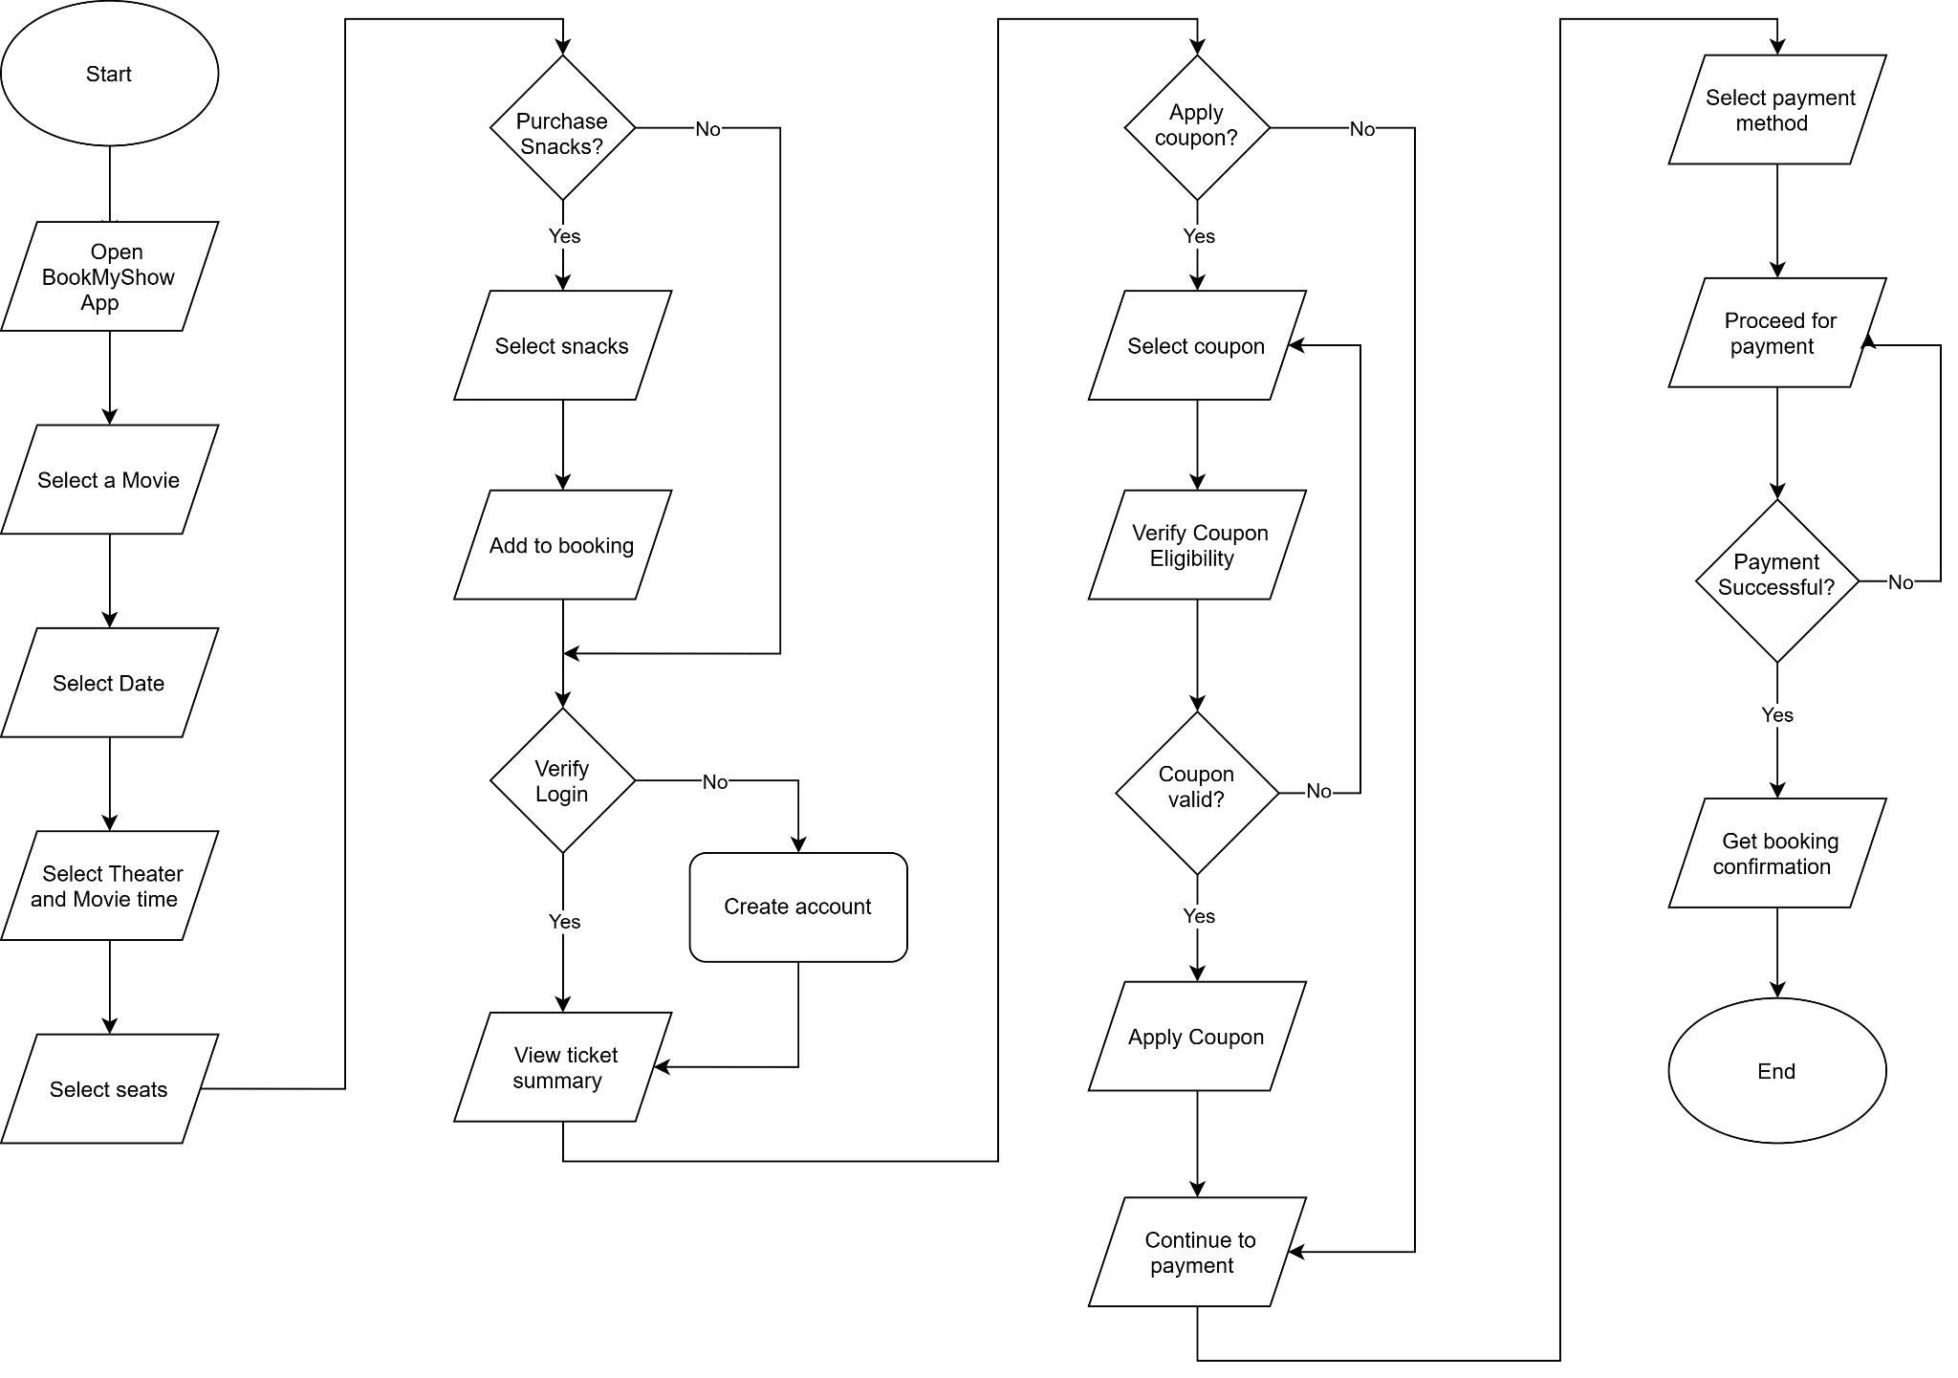
Write down the steps (as an algorithm, using simple numbered instructions) for ordering food on Swiggy — from opening the app to completing payment.
- Open the app
- Enter mobile number or skip if allowed.
- Select a restaurant/cafe
- Select food items
- Go to the cart
- Add custom instructions for the kitchen/chef
- Apply a coupon if applicable
- Create or log in to your account if required
- Select the payment method
- Proceed with the payment
- Receive order confirmation and view the live order status

